Meet #4 – Category 2

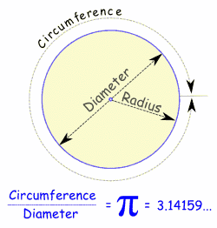

Self-study Packet
- Mystery: ?
- Geometry: Properties of circles
- Number Theory: Modular arithmetic, series and sequences
- Arithmetic: Percent applications: find percent of a number, find what percent a number is of another, find a number where the percent of that number is known, find percent of change
- Algebra: Word problems (linear, including direct proportions or systems)
visit http://www.imlem.org
Meet #4 – Geometry – Ideas you should know
Circles: All points are the same distance from the center.
Radius, Diameter, Circumference, Area:
Radius is the distance from the center to the edge
Diameter starts at one side of the circle, goes through the center and ends on the other side.
So the Diameter is twice the Radius
Diameter = 2 × Radius
Circumference is the distance around the edge of the circle = 2 × π × Radius
Area of interior = π × r²

Example: What is the area of a circle with a circumference of 12.56 cm? Use π = 3.14.
Answer: C = 2πr, so r = C/(2π) = 2. A = πr² = 3.14 x 2² = 12.56 cm².
5
5
135°
Area of partial circle:
A = Area of circle x Fraction of Circle
Example: What is the area of a slice of cherry pie with a central angle of 135°
and a diameter of 10 inches? Use π=3.14. Round to nearest tenth.
Answer: R=5 in, area of total circle = πr² = 25π = 78.5 in²,
fraction of circle = 135°/360°= 0.375, area of slice = 78.5 x 0.375 = 29.4 in².
5
5
60°
Circumference of a slice of pie:
Example: What is the circumference of this 60° fraction of a circle with a radius = 5 in? Use π=3.14. Round to tenth.
Answer: The circumference would be 2πr=10π, but this is 60/360 = 1/6 of the circle, so the curved edge is 10π/6. We add on the two straight parts, 5 in each, for a total of 10π/6 + 5 + 5 = 15.2 in².

Adding / Subtracting Areas:
2
Example: A circle of diameter 2 inches sits in a square with all 4 sides tangent to (touching) the circle, as shown. What is the area of the shaded region outside the circle? Use π=3.14. Round to the nearest tenth.
Answer: The area of the white circle is πr² = π1² = 3.14, and the area of the square is 2² = 4, so the shaded region is 4 - 3.14 = 0.86 in²

Scaling a shape in 2 dimensions – Area scales by the square:
2X
Shape twice as big
Area 2² = 4 times bigger
A=1

A=3²
3X
Shape 3 times as big
Area 3² = 9 times bigger
A=1

Scale Ratio is Square Root of Area Ratio:
If square B has twice the area of square A, then B’s side length is √2 times as big as A’s side length.
2X Area
Side Length 1
Side Length √2
(about 1.414)
Area
= 2

Area = 1

r
R
Example: A smaller circle of radius r is enclosed within a larger circle of radius R as shown. The area of the shaded region between the circles has the same area as the smaller circle. What is R/r, rounded to the nearest 0.001?

Answer: You could do this with algebra, but a simpler way is to realize that the larger circle has twice the area of the smaller circle, and so it has √2 times the radius, or 1.414. The first part of the secret word is obfus. Use both parts when asked so we can find out that you are the one who actually reads this.
Doing it the hard way with algebra:
Shaded area = (πR²-πr²) = πr² = smaller circle’s area
Add πr² to each side: πR² = 2πr²
Divide each side by π: R² = 2r²
Take the square root of each side: R = (√2) r, or R/r = √2 = 1.414…

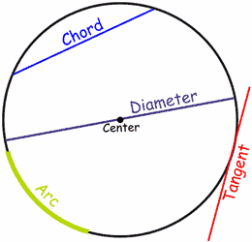
Lines
A line that goes from one point to another on the circle's circumference is called a Chord.
If that line passes through the center it is called a Diameter.
If a line "just touches" the circle as it passes it is called a Tangent.
And a part of the circumference is called an Arc.
Inside and Outside
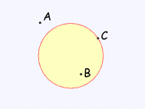
A circle has an inside and an outside (of course!). But it also has an "on", because you could be right on the circle.
Example: "A" is outside the circle, "B" is inside the circle and "C" is on the circle.

Angles
Inscribed Angle: An angle in a circle with the vertex on the circle itself.

Central Angle: Any angle whose vertex is the center of a circle.
Minor Arc: The smaller of the 2 arcs made by a Central Angle.
Major Arc: The larger of the 2 arcs.
Minor Arc
Arc Angle: Measure of the Central Angle that intercepts it.
Central Angle;
Arc Angle = 90°
Major Arc

Inscribed angle is HALF of the central angle:
Inscribed Angle AFC is half of the corresponding Central Angle AOC

It doesn’t matter where point F is as long as it is on the major arc of AOC

50°
100°
A
F
C
O

50°
100°
A
F
C
O

12
9
3
6
90° Central Angle

45° Inscribed Angle
(half Central Angle)
12
1
9
3
6

12
9
3
6
180° Central Angle

90° Inscribed Angle
(half Central Angle)
12
1
9
3
6

Slices
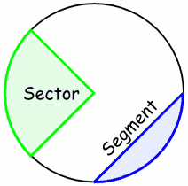
There are two main "slices" of a circle
The "pizza" slice is called a Sector.
And the slice made by a chord is called a Segment

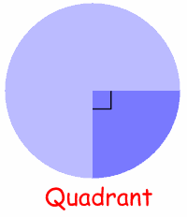
Category 2
Geometry
You may use a calculator today!
Meet #4, February 2005

1. A certain circle has a circumference of 125.6 feet. How many square feet are in the area of the circle? Use 3.14 for pi and round your result to the nearest whole number.

Hint: Find the Radius from the Circumference. Now use that to find the area. Be sure to round.
2. In the figure at left, point B is the center of the circle. The measure of angle ACB is 65 degrees and the measure of angle BCD is 14 degrees. How many degrees are in the measure of angle ADC?

Hint: Note that ACB is Isoceles (AB=CB=R), so angle CAB is also 65°. What is the central angle ABC? ADC next!

3. The side length of the square in the figure below is 2 inches. The arcs are all 90 degree arcs of circles with radius 1 inch and the small white circle has a diameter of 1 inch. How many square inches are in the area of the shaded region? Use 3.14 for pi and round your result to the nearest tenth of a square inch.

Answers
1. _______________
2. _______________
3. _______________

Hint: Draw a line across the center, dividing into a top 1x2 rectangle and a bottom 1x2. The top now looks like a rectangle minus half a circle. The bottom is half a circle minus a smaller circle.
Solutions to Category 2
Geometry
Meet #4, February 2005 (Students got only 1.07 of these 3 correct on average.)

1. The circumference of a circle is given by the formula where D is the diameter or by where r is the radius of the circle. We are given the circumference, so we can divide by pi to find the diameter or twice the radius. 125.6 ÷ π ≈ 125.6 ÷ 3.14 = 40. So the diameter is 40 feet and the radius is half that, or 20 feet. The area of a circle is given by the formula 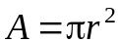. Our circle must have an area of π × 20² or about 3.14 × 400 which is 1256 square feet.
Answers

1. 1256

2. 25

3. 1.2

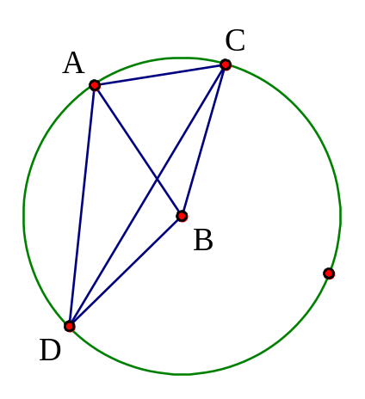 | 2. Sides AB and BC are radii of the circle, so triangle ABC is isosceles. This means angle BAC has the same measure as angle ACB, namely 65 degrees. Together angles BAC and ACB account for 130 degrees, so the measure of angle ABC must be 180 – 130 = 50 degrees. Angle ADC is known as an iscribed angle and has exactly half the measure of the central angle that intercepts the same arc. Therefore, the measure of angle ADC is 50 ÷ 2 = 25 degrees. Note that we do not need to know the measure of angle BCD.

3. One way to find the area of the shaded region is to divide the square into quarters. We can then see that the two shaded portions in the top half of the square fit perfectly in the two unshaded regions of the lower half of the square, as shown by the arrows. Now we only need to subtract the area of the small circle from half the area of the square. This gives
= 1.215 or 1.2 to the nearest tenth of a square inch.
Category 2
Geometry
You may use a calculator today!
Meet #4, February 2004
A
B
C

1. Segment AC is a diameter of the circle at right. If the measure of angle CAB is 49 degrees, how many degrees are in the measure of angle ACB?

Hint: If O is the center, then central angle AOC is 180°. ABC is an Inscribed Angle, and Inscribed angles are half the corresponding central angle.

2. A circle is inscribed in a square whose area is 2.25 square inches. How many square inches are there in the sum of the areas of the two shaded regions? Use 3.14 for π and express your answer as a decimal to the nearest hundredth.

Hint: What is the side-length of the square? What is the radius of the circle? Subtracting areas will get you close.

3. Find the number of feet in the radius of a circle whose area given in square yards is numerically equivalent to its circumference given in feet.
(Reminder: Three feet equals one yard.)

Answers
1. _______________
2. _______________
3. _______________

Hint: How many square feet are there in a square yard? Not 3!
Do your computations all in feet to avoid confusion.
Solutions to Category 2
Geometry
Meet #4, February 2004
Answers

1. 41

2. 0.24 or .24

3. 18
1. Since segment AC is a diameter, angle B must be a right angle. This means that angles A and C must add up to the other 90 degrees in the triangle. 90 – 49 = 41, so the measure of angle ACB must be 41 degrees.

2. If the area of the square is 2.25 square inches, its side length is the square root of 2.25, which is 1.5 inches.
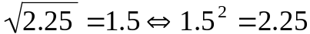
The side length of the square and the diameter of the circle are the same. The formula for the area of a circle is 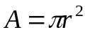, so we need the radius of the circle, which is 1.5 ÷ 2 = 0.75 inches. The area of the circle is thus square inches. Subtracting this from the area of the square, we get 2.25 – 1.76625 = 0.48375 square inches. The two shaded regions account for half of this difference, or 0.48375 ÷ 2 = 0.241875 square inches. Rounding this to the nearest hundredth, we get 0.24.

3. We have A = C, but A is in square yards and C is in square feet. Since we would like to write a single equation to solve for the unknown radius, we should convert the area of the circle from square yards to square feet. There are three feet in a yard, but nine square feet in one square yard (see picture at left). Our conversion will make the numerical value of the area nine times greater. We will have to multiply the value of the circumference by nine to keep these two quantities numerically equal. Thus we have the equation . Since 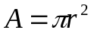 and , we have 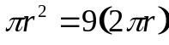. Dividing both sides by πr, we get r = 18 feet.
One square yard equals
nine square feet.
Category 2
You may use a calculator today!
Geometry
Meet #4, February, 2003
1. In the figure at right, the measure of minor arc AB is 70 degrees. How many degrees are in the measure of the inscribed angle ADB?

Hint: There is a rule for this that you should know. When you
move from the center of the cirlce (C) to any point on the circle
(such as D) then the angle is half of what it was.

T
L
S
2. The two circles in the figure at left are tangent at point T, meaning that they touch at that single point. The radius of the smaller circle (ST) is three fourths the radius of the larger circle (LT) and the radius of the larger circle is one inch. How many square inches are in the area of the shaded region? Use 3.14 for π and round your answer to the nearest hundredth of a square inch.
Hint: You can find the area of the bigger (dark) circle, since you know its radius (one inch). What is the radius of the smaller circle? Use that to find the area of the smaller (white) circle. Subtract to find the area between them.

3. Bobby rigged up a funny bicycle with a big wheel in the back and a small wheel in the front. If the back wheel has a diameter of 27 inches and the front wheel has a diameter of 24 inches, about how many more times will the front wheel go around than the back wheel during a one-mile ride? There are 5280 feet in a mile and 12 inches in a foot. Use 3.14 for π and round your answer to the nearest whole number of rotations.

Answers
1. _______________
2. _______________
3. _______________

Hint: What is the circumference of the big back wheel? This is how far it goes for each revolution. Convert from inches to feet.
What is the smaller front wheel’s circumference in feet?
For each wheel, how many revolutions does it take to go 5280 feet?
Solutions to Category 2
Geometry
Meet #4, February, 2003
Answers

1. 35

2. 1.37

3. 93 **
1. The measure of an inscribed angle is half the measure of the arc it “subtends”. Thus angle ADB measures half of arc AB which is 70 ÷ 2 or 35 degrees.

2. To find the area of the shaded region, we can subtract the area of the smaller circle from the area of the larger circle. The area of the larger circle is π square inches, since the radius is 1 inch and 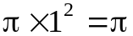. The area of the smaller circle is 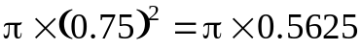. The difference is . Using 3.14 and rounding to the nearest hundredth of a square inch, we get 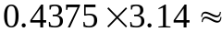1.37 square inches.

3. The back wheel with a diameter of 27 inches will travel 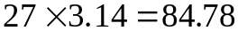 inches with each revolution, or about 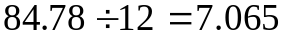 feet. The back wheel will rotate about times in one mile. The front wheel, on the other hand, with a diameter of 24 inches will travel 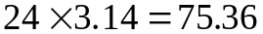 inches with each revolution, or about 6.28 feet, and will rotate about 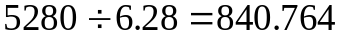 times in one mile. Thus the front wheel will rotate about times more than the back wheel, which is 93, to the nearest whole number.

** The rest of the secret word is cated.
Category 2
Geometry
You may use a calculator today!
Meet #4, February, 2002

1. A certain circle has a circumference of 18.84 centimeters. How many square centimeters are there in the area of the circle? Use 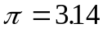 and express your result to the nearest hundredth of a square centimeter.

Hint: Find the radius of the circle, first.

4. The two concentric circles shown at right were constructed so that the area of the shaded ring is twice the area of the inner circle. If the radius of the smaller circle is 1 centimeter, what is the radius of the larger circle? Give your answer to the nearest thousandth of a centimeter. | r  R

Hint: What is the area of the smaller circle (r=1)? What is the area of the shaded region? What is the total area of the larger circle? Now what is R? Remember to round to nearest 0.001

3. According to the ancient Egyptian Ahmes’ papyrus, the area of a circle can be found by subtracting one-ninth of the diameter and then squaring the result. Find the area of a circle with a diameter of 10 feet by both the ancient Egyptian method and by our modern formula using 3.1416 for Pi. How many square feet are in the positive difference between these two calculations of the area of the circle? Round your answer to the nearest ten-thousandth.

Answers
1. _____________
Hint: If the diameter is 10 feet, what is 8/9 of that?
What is the radius? What is the modern value of the area?
Round your final answer to the nearest 0.0001
2. _____________
3. _____________

Solutions to Category 2
Geometry
Meet #4, February, 2002

Answers  r  R  1. 28.26  2. 1.732  3. 0.4723 ** | 1. Given a diameter of a circle, its circumference can be found using the formula, 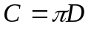. On the other hand, if the circumference is known, the diameter can be found be the formula 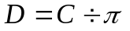. Our circle has a circumference of 18.84 cm, so its diameter must be 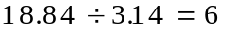 cm. A diameter of 6 cm means the radius measures 3 cm. The area of the circle is thus 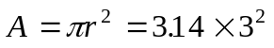 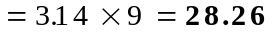 square centimeters.  2. Since the shaded ring has twice the area of the inner circle, the circle of radius R must have exactly three times the area of the inner circle. This gives us the equation: 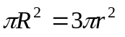. Substituting 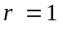 and solving for R, we get 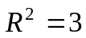 or 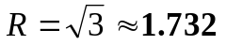 to the nearest thousandth of a centimeter.

3. By the ancient Egyptian method, the area of a circle with a 10-foot diameter would be calculated as follows:
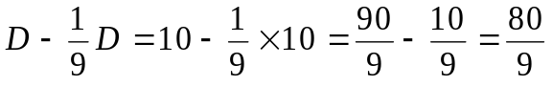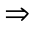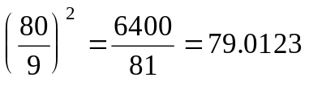 sq. ft.
Using the formula 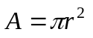, with 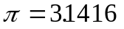 and a radius of 5 feet, we get: square feet. The positive difference between these two calculations is , or a little less than one half of a square foot.
Note: You can find what Ahmes’ value of π must have been: C = (2R x 8 / 9)², or R² x (16/9)² = R² x 256/81 = R² x 3.16. A more accurate ratio for π would be 355/113 = 3.141593
** The second part of the secret word is cated.
Category 2
Geometry
You may use a calculator today!
Meet #4, March 2001

1. In the figure shown below, the radius of each of the small circles is 2 cm. Find the area of the shaded region. Use 3.14 as an approximate value of pi and express your answer as a decimal to the nearest hundredth of a square centimeter.

Hint: What is the side-length of the square? What is area of square? Area of each circle or half-circle?
2. The two concentric circles shown below were constructed so that the area of the shaded ring equals the area of the inner circle. If the radius of the smaller circle, r, is 1 centimeter, what is the radius of the larger circle, R? Give your answer to the nearest thousandth of a centimeter.
r
R

Hint: Find the area of the smaller circle, then the area of the shaded region, then the area of the larger circle.

3. In the figure below, 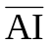 is a diameter of the circle and both C and T are points on the circle. If the measure of angle CAT is 83 degrees and the measure of angle TAI is 56 degrees, find the measure of angle CIA. Express your answer in degrees.
Hint: Find angle CAI first, then realize what angle ACI must be (inscribed angle), and then you can compute CIA.

Answers  1. _____________  2. _____________  3. _____________ | 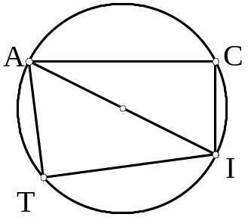

Solutions to Category 2
Geometry
Meet #4, March 2001

Answers  1. 13.76  2. 1.414  3. 63 | 1. The area of the entire square is 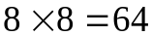 square centimeters. From this, we must subtract the area of the semicircle and each of the small circles. The area of the semicircle is 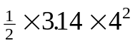 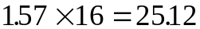 square centimeters. The area of the two small circles is 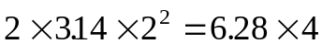 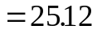 square centimeters. The area of the shaded portion of the figure is thus: square centimeters.  2. Since the shaded ring has the same area as the inner circle, the circle of radius R must have exactly twice the area of the inner circle. This gives us the equation: 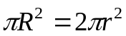. Substituting 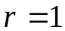 and solving for R, we get 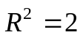 or 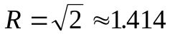 to the nearest thousandth of a centimeter.  3. Since is a diameter of the circle and both C and T are points on the circle, the angles ACI and ATI are right angles. Angles CAT and TAI are given. The remaining angles can be worked out easily. The measure of angle CIA is 63 degrees.  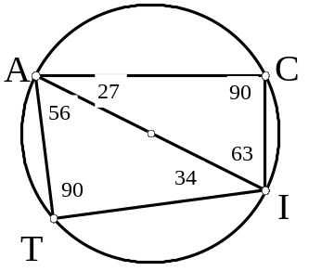

M4C2 Geometry Self-Test: Use π = 3.14 (or express answer in terms of π)

- You have a circle of diameter 20. What is its area?
- You have a circle of circumference 31.4 and you need to know the area. What is it?
- On a round 12-hour clock, draw an inscribed angle from 4 to 2 to 10. What is the measure of the angle at the vertex at 2?
6
4
10
- On a round 12-hour clock, draw an inscribed angle from 6 to 4 to 10. What is the measure of the angle at the vertex at 4?
- Your back yard has 9 times the area of my back yard, but they are both the same shape. If the largest dimension of your yard is 120 feet, what is the largest dimension of my yard?
- You cut a piece of paper into a circle of radius 10 cm. Now you cut a square out of it that is 4x4 cm. What is the remaining area? (one side of the paper only of course).
- (Genius) Draw a circle of radius 1 centered at the point (-1,0). Draw another of the same size at point (1,0). Now draw the top half of the circle of radius 1 centered at point (0,1). What is the area within the top circle but outside of the two bottom circles?
A
B
C
D
40°
E
95°
?
Angle BAC is 40°
Angle AEB is 95°
What is angle BDC?
Drawing may not be to scale.
Hint:Find angle at B, then angle at C, then CED

Answers:
- R=10, A=πR²=100π=314
- C=2πR=31.4, so R=31.4/(2x3.14) = 5. Area = πR² = 25π = 78.5
- 90°. 4-10 is a diameter (central angle of 180°) so 4-2-10 must be half that
- 60°. 6 to the center and then to 10 is 120° (4/12 of 360°) so 6-4-10 must be half that
- 40 feet. 3 times the scale gives 9 times the area (for same shape).
- 298 cm². The circle is area 314, the square is 16, 314-16=298.
- Rounded to the nearest millionth, the answer is the fifth root of 32. Must be a Genius.
- 40° (Angles A and D are both inscribed angles for arc BC, and so have same measure.)
Meet#4 Team/Mystery Round Questions on Geometry
2003 M4C6 #1. In the circle shown here, the measure of angle BOT equals one-half the sum of arc angles AND and BUT. If the measure of arc angle AND is 53 degrees and the measure of arc angle BUT is 39 degrees, how many degrees are in the measure of angle DOT?

2003 M4C6 #5. In the figure at right, circles A and B are tangent at point C. Circle A has a radius of 1.75 cm and circle B has a radius of 1.05 cm. What is the ratio of the area of circle A to the area of circle B? Express your answer as a mixed number in lowest terms.

2005 M4C6 #1. The interior angles of a quadrilateral form an arithmetic sequence. If the measure of the largest angle is 132 degrees, how many degrees are in the measure of the second largest angle?

B  C | 2005 M4C6 #3. In the figure at left, segment BC is a diameter of the circle. Segment AB has a length of 8 units and segment AC has a length of 15 units. How many square units are in the area of the shaded region? Round your result to the nearest whole number of a square units.  Hint: Find angle A (inscribed angle); find length of BC; find radius; find area of triangle.

2005 M4C1 (Mystery) #1. In the picture below, quadrilateral ABCD is a rectangle and quadrilateral EFGH is a parallelogram. Vertices H and F of the parallelogram meet the short sides of the rectangle one third of the way up or down those sides. Vertices E and G meet the longer sides of the rectangle one quarter of the way from the left or right end of those sides. What fraction of the rectangle is shaded? Express your answer as a common fraction in simplest terms.
A
B
C
D
E
F
G
H
Answers:
Full solutions at www.imlem.org
2003 M4C6 #1) 134°
2003 M4C6 #5)
2005 M4C6 #1) 104
2005 M4C6 #3) 167 (circle = 227, triangle=60)
2005 M4C1 #1) 5/12

