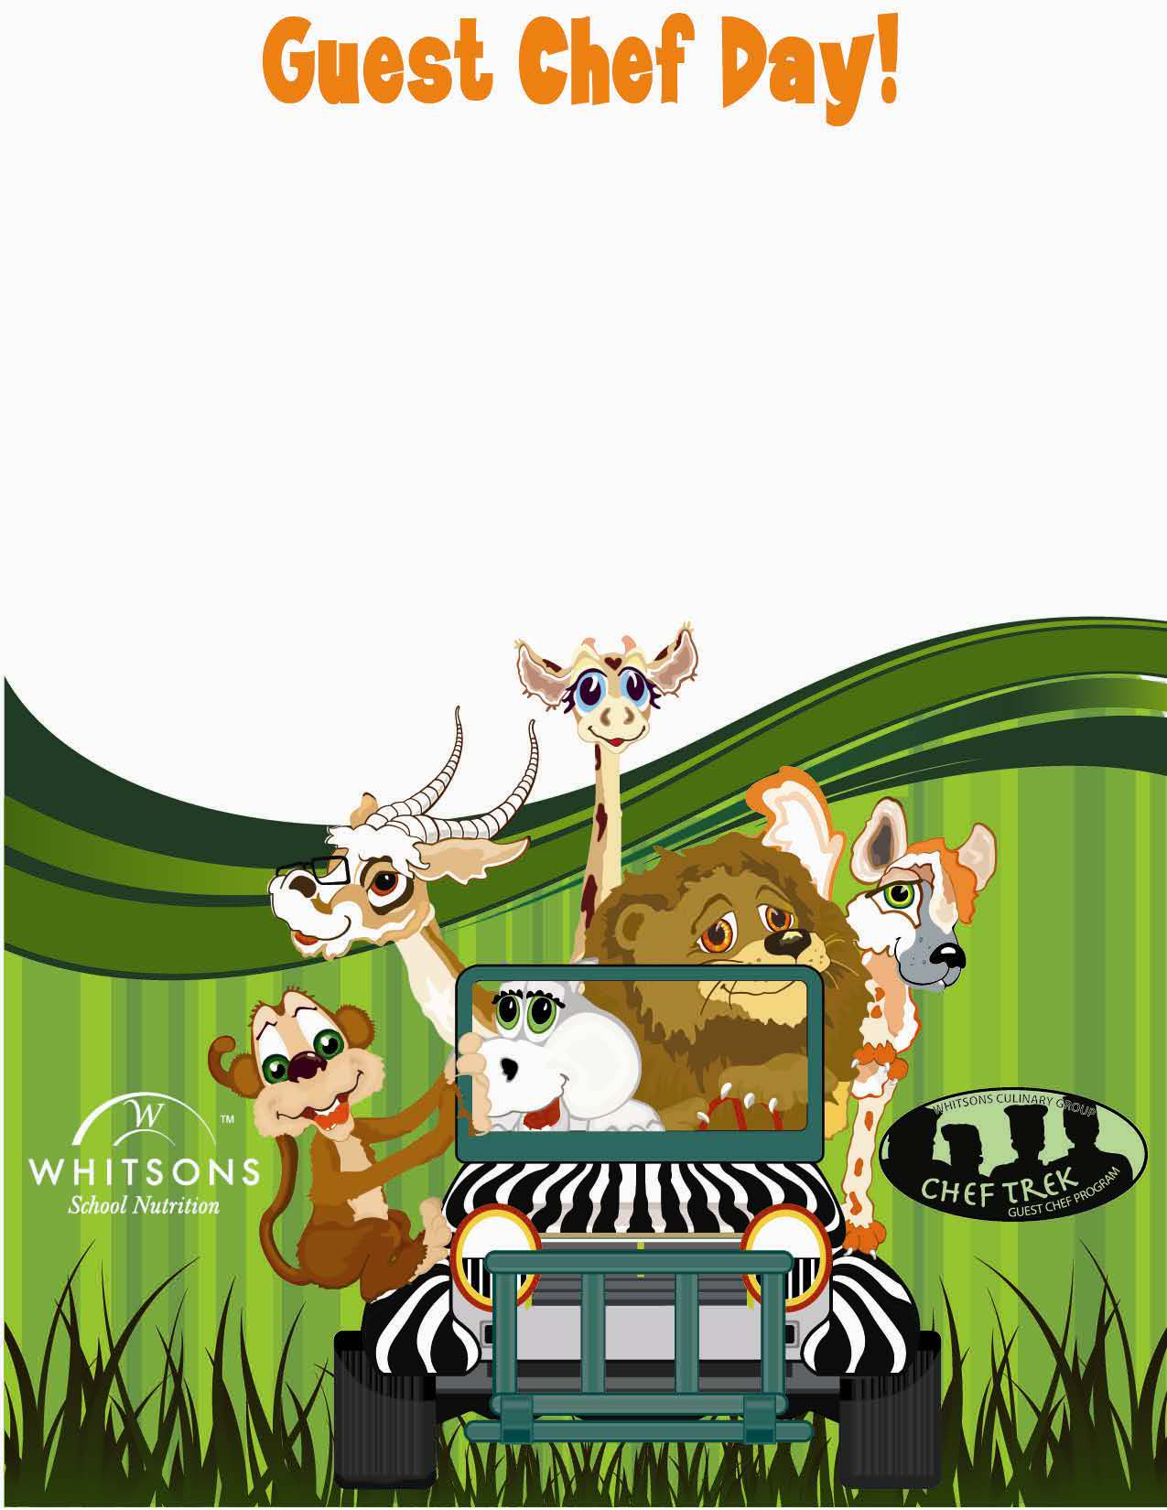

**Cinnamon Apple Banana Smoothie**

**Makes 6, 2 oz smoothies**

**One medium apple, ½ cup, medium diced with skin, Macintosh, granny smith, Cortland, you choose**

**One medium ripe banana, ¾ cup**

**½ cup low fat or fat free vanilla yogurt**

**¼ cup apple juice, chilled**

**¼ cup orange juice, chilled**

**¼ tsp cinnamon**

1. **Using a blender or smoothie maker, pulse the apple**
2. **Add banana, yogurt, juice and cinnamon**
3. **Blend well to create a fall time favorite.**

**By: Chef Kim**

**Cinnamon Apple Banana Smoothie**